Quick Guide to accessing the Learning Place – Class Course
- Google search the Learning Place
Use Chrome or Firefox or Microsoft Edge to access (it doesn’t love Internet Explorer)
- Follow the steps below
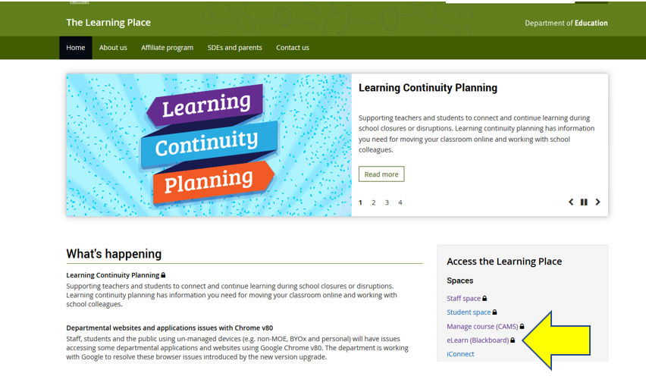
Use your MIS ID (the first half of your email address) plus your password to log in. If you don’t know your password or MIS ID, please call the school Administration office.
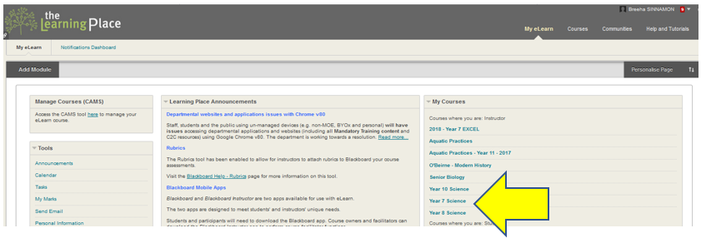
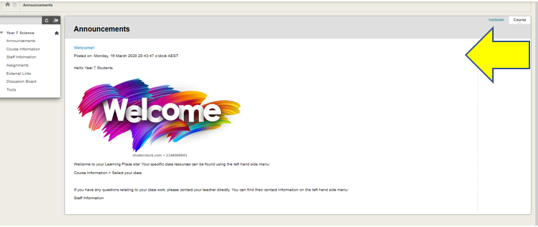

Quick Guide to accessing the Learning at Home Resources
- Follow this link:
https://education.qld.gov.au/curriculum/learning-at-home
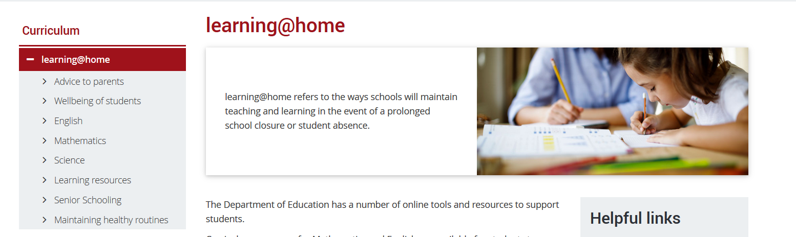
Click through the relevant sections that you are needing to access.
